Ideation Phase
Brainstorm & Idea Prioritization Template

Date | 23 June 2026
Team ID | 23A51A05M8
Project Name | Leave Approval System
Maximum Marks | 4 Marks

Brainstorm & Idea Prioritization Template:
Brainstorming is a structured creative thinking process that helps teams generate a wide range of ideas to solve a problem. During this phase, all possible solutions are discussed without immediate evaluation, encouraging creativity and collaboration among team members. The generated ideas are then grouped based on their similarities, analyzed for feasibility, impact, and practicality, and finally prioritized to identify the most effective solution.
For the Leave Approval System, brainstorming was conducted to identify the key features required for an efficient leave management process. Various ideas such as an online leave request form, automated approval workflow, email notifications, leave record management, and reporting dashboard were explored. After evaluating these ideas, the team selected the most feasible and user-friendly solution that could be implemented using the ServiceNow platform.
The ideation process helped in understanding user requirements, improving the system workflow, and ensuring that the final solution addressed the challenges of manual leave management. The selected features were further organized into a workflow diagram and prioritized based on their importance and ease of implementation.
Reference: https://miro.com/templates/brainstorming/

Flowchart of Leave Approval System
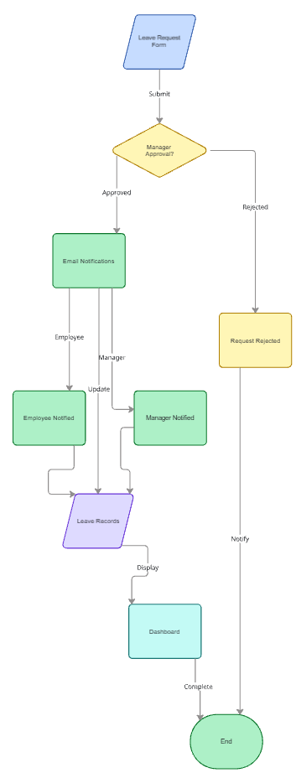

Working Diagram of Leave Approval System
